ER #76 Fraser River – September 19 & 20, 2026
Report by Bev and Bill Ramey

Sunny both days, but hazy in the morning. The Lower Mainland exhaust pollution cleared enough in the afternoon so that the distant peaks of the Lucky Four and Slesse Peak became visible.
We were on islands both days from approximately 11:30 am to 6:00 pm.
Water level at Mission gauge both days: approx. 0.0 metres to 1.6 metres (tidal)
Water level at Hope gauge: 3.70 metres on Sept 19 and slightly lower on Sept 20 at 3.65 metres
Participants were Bill and Bev Ramey, EcoReserve Wardens.

This was the lowest water level we’d seen on the Fraser River during our 24 years as wardens. This is the season for spawning salmon (not on the gravel bars of ER#76 as the Pink Salmon spawn only every second year in odd-numbered years), so rain is desperately needed for the many salmon species heading upriver on the Fraser and its many tributaries. We camped overnight at nearby Chehalis River which is also well below its normal level and the Harrison River too.

With the low water level and general dryness over the past three months, the herbaceous vegetation on the gravel and sand bars of the islands was stunted and more scattered than past years. Compared to previous years, very few dragonflies were visible, nor grasshoppers, nor insects generally. We saw only a few Alder Flea Beetles on the Sandbank Willow leaves.

The low water level provided easier walking for us as we did not have to wade any interior water channels. Many of the interior ponds and pools the would usually have been flowing channels were drying up.

On nearby Nicomen Island, extensive work has been done, shoring up dykes near our launch location (signage stated work took place January to June). Loads of new boulders have been placed in an area about 200 metres upriver from the old boat launch. That former boat launch, which had not been used for more than a decade, has had its concrete ramp broken up and piled behind. There is now a steep sandy eroding bank from which to lower our kayaks. As water levels rise, this launch point may become more challenging.

The first day we explored the lower two islands. We paddled further downriver than in past years to the accreting island off the northwest downriver tip of the ER. The cottonwoods on this accreting island are now up to five metres tall. From that island we were able to walk across the extensive gravel, sand, silt, clay accreting river bars to the main downriver island where we walked its shoreline to its downriver tip. Then we walked up the central channel between the lower islands. The southern shoreline of these islands has considerable accreting gravel/sand bars extending southwards to the main river channel that now flows close to the base of Chilliwack Mountain.

As we walked the sand and gravel shorelines, many tracks of deer, coyote and bear were visible. The two sizes of bear tracks looked to be a mother and cub. Tracks were visible where we’d landed our kayaks (on accreting island closest to Nicomen Island) and bear feces seen on the main downriver island included visible corn kernels, so we think the bears are swimming across the river channels to Nicomen Island where they had been feeding on corn fields.

Next we traversed inland through the interior of the largest downriver island. The inland pool (where we’d seen Northwestern Salamander eggs during several springtime visits and last September where our group saw two swimming garter snakes) still held some water and several tadpoles were swimming about. This portion of the inland route across the island was fairly accessible, walking through the Reed Canarygrass and Scouring-rush Equisetum, under large Pacific Willow trees. However, the last third of this route was badly overgrown with Himalayan Blackberry.

At the end of the day we paddled upriver along the island shoreline to then paddle our kayaks back across the Fraser River channel to Nicomen Island. We noticed two Common Ravens feeding on something along the ER shoreline. They flew off as we paddled closer and we could see a large dead Sturgeon, almost two metres in length. Its skin and flesh had been pulled off from its upper spine, just below its head. Its innards had been pulled out and were lying beside it on the sand.

On Monday we reported the dead sturgeon to the Lower Fraser Sturgeon Society, who provided us the Provincial website to report dead sturgeon and who have uploaded our information to that website (GPS and seven photos). We could not see any visible tags or identification on the Sturgeon. On Sunday morning we had another look and saw that the Sturgeon’s body had been dragged a little and was now bent in half. Its innards were all gone and there were many coyote footprints about. Late afternoon from a distance we saw an eagle pecking at its carcass.

Sunday morning, we began our walkabout on the upper islands. We walked upriver to the area we’d previously named the Sand Dune, which now has cottonwoods up to five metres tall. The small pool near those larger trees was considerably dried up, but there was an aquatic animal that looked like Pacific Lamprey sunning on the wet sand at the edge of the pond. A cattail stem was used to gently push it back into the pool, where it swam off readily. Mike Pearson (Pearson Ecological) has confirmed from a photo that it was likely a Pacific Lamprey (Entosphenus tridentatus), but that it might have been a Western Brook Lamprey or a River Lamprey. These latter two are mostly associated with smaller rivers, so most likely it was a Pacific Lamprey. To confirm species, it is necessary to examine its teeth which we did not do. Michael explained it looked like the lamprey had just emerged from the mud and transformed from the larval (ammocoete) to adult. Lampreys spend 3 to 7 years as filter feeding larva. The adult would soon make its way to the ocean for a couple of years, but of course that would require higher water levels. An iNaturalist comment however suggested best to list at family, without the teeth information, so: Northern Lampreys, Family Petromyzontidae. Possibly within that family: Western River Lamprey Occidentis ayresii.

We continued around the upriver tip and then back downriver along the southern facing side. We were able to walk and scramble along its eroding shoreline, which was helpful as that island’s young alders and cottonwoods have extensive under-growth of Himalayan Blackberry. We next walked across a gravel bar to the second upriver island, where we were able to walk through its deciduous forest, where blackberry growth has not yet taken hold. This island’s trees are larger, including a few Douglas fir and Hemlock.

Its circular pond still had considerable water that looked to be above the water level of the Fraser. We think the silt and clay at the base of this pond is acting like a membrane to hold its water. There were a few dragonflies flying about here, but their numbers were much reduced from previous years. There were some tadpoles in this pool.

We next made our way back towards our kayaks across where the several inland channels meet (now mostly dry). On examination of the last long narrow water pool near the higher treed area of the upper island, we saw four eel-like fish that looked like Pacific Lampreys of different sizes sunning themselves just above the water’s edge. These looked similar to the one seen earlier today. Again, when pushed back into the water they each readily swam off. In the pond were several tadpoles. There were also two empty mussell shells of Western/Oregon Floater (Anodonata kennerlyi/oregonensis clade). We’d never found these freshwater mussell shells in this area before, only in the previously mentioned pond within a treed island. Perhaps these shells have become visible with this low water level. There were also extensive toe-footprints of Great Blue Herons in the surrounding mud, so we think the herons have been feeding over many days at this drying up pool.

There seemed to have been very little human activity on any of the islands. No garbage was found, which is very nice to report. In previous visits, especially over a decade ago, there were often areas where people had camped and left remains such as shelters or outhouses. There were two areas with signs of aircraft landing. Helicopters have been landing on an accreting sandbar a good distance out from the treed islands. A large square had been marked in the sand which looked to define an area where helicopter landings had taken place within that square, likely for training. On the wide accreting northern side of the upriver largest island there were wheel tracks from fixed-winged aircraft landing.

Species Observed
Species observed during the two days have been added to the already extensive photos posted on iNaturalist at this link:
https://www.inaturalist.org/projects/fraser-river-ecological-reserve
For ER #76 there are now 2,304 observations posted of 467 species.

Mammals
Coyote: many tracks seen throughout the islands
Deer: many tracks seen throughout the islands.
Bear – a large and a small set of recent tracks seen in several locations
Beaver – tracks and workings visible in many locations.

Amphibians and Reptiles
Western Toad (Anaxyrus boreas) – one adult seen
Pacific Tree Frog (Pseudacris regilla) one seen
Tadpoles – observed in three of the inland ponds
Columbia Spotted Frog (Rana luteiventris)
Common Garter Snake (Thamnophis sirtalis) – two young ones seen in two different locations along gravel accreting shoreline

Fish
White Sturgeon (Sinosturio transmontanus) – one dead along shoreline
Pacific Lamprey (Entosphenus tridentatus) in the Northern Lamprey Family (Petromyzontidae). Or another possible species ID is Western River Lamprey (Occidentis ayresii) – five observed next to drying out ponds, likely just emerged from mud transformed from its larval form to adult.
Salmon fingerlings – visible in drying up pools

Molluscs
2 Western/Oregon Floater shells, (Anodonata kennerlyi/oregonensis clade)

Insects
Very few insects seen; considerably fewer than during previous visits.
A few dragonflies and damselflies seen at the circular inland pool.
A few Alder Flea Beetles (Altica ambius) feeding on Sandbar Willows

Plants
Frank Lomer has continued to identify plants on this ER. His list totals 412 species, as of September 10, 2026. This includes: 20 trees, 33 shrubs, 240 forbs, 59 grasses, 23 sedges, 13 rushes, 13 aquatics, 6 ferns, 3 horsetails, and 2 liverworts. No mosses have been included in this plant list. Plant list posted on Friends of Ecological Reserves website.

Birds
Daily tally entered on eBird hotspot:
https://ebird.org/hotspot/L844938

September 19th birds:
Glaucous-winged Gull 2
Great Blue Heron 1
Belted Kingfisher 1
Bald Eagle 2
Northern Flicker 1
Downy Woodpecker 1
Hairy Woodpecker 1
Common Raven 2
Black-capped Chickadee 1
Golden-crowned Kinglet 1
Varied Thrush 1
American Robin 5
Dark-eyed Junco 1

September 20th birds:
Red-breasted Merganser 1
Short-billed Gull 10
Glaucous-winged Gull 2
Great Blue Heron 1
Bald Eagle 1
Accipiter species 1
Northern Flicker 1
Western Warbling Vireo 1
Black-capped Chickadee 1
Pacific Wren 1
American Robin 1

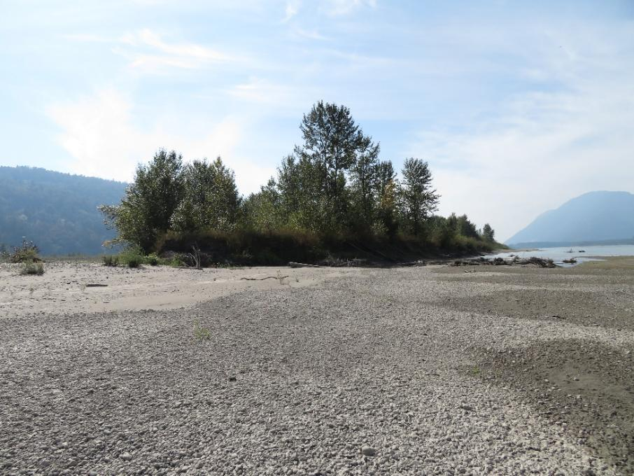
The newly accreting island northwards from the downriver tip of the western-most island, where cottonwoods have grown up to five metres tall

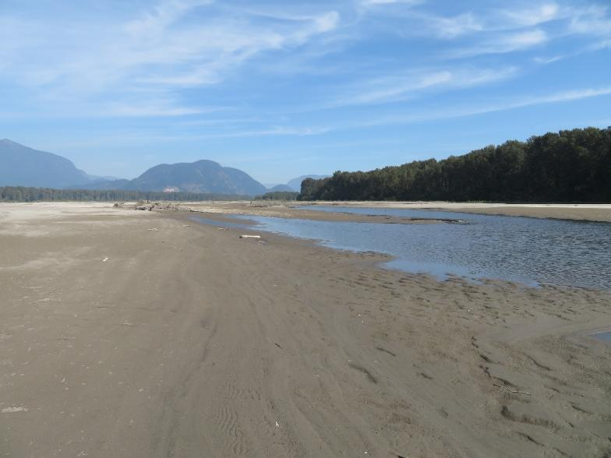
Looking upriver across the extensive accreting shoreline and on photo right, the largest downriver island. Harrison Hill and Knob show in the distance, photo centre

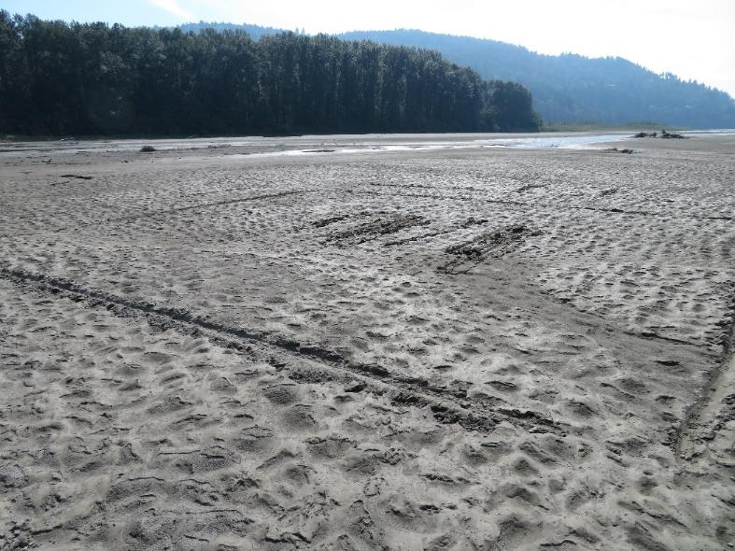
Possible helicopter landing training area: large square marked in sand/silt and with several landing skid marks in its centre.
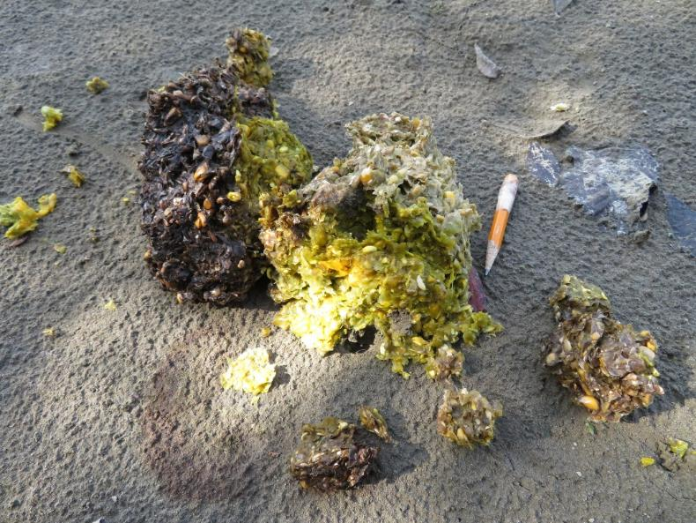
Feces from black bear showing corn kernels. Short pencil included for scale.

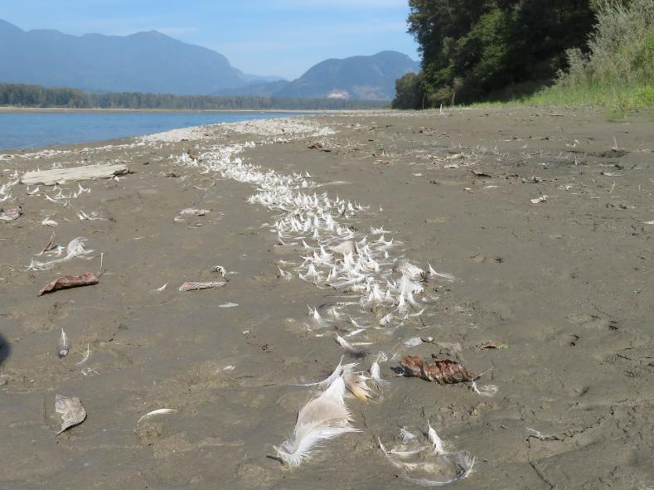
Extensive feathers from waterfowl (likely molted from Mallard Ducks) washed up along shoreline of largest downriver island. No mallards were seen during our two-day visit to the islands.
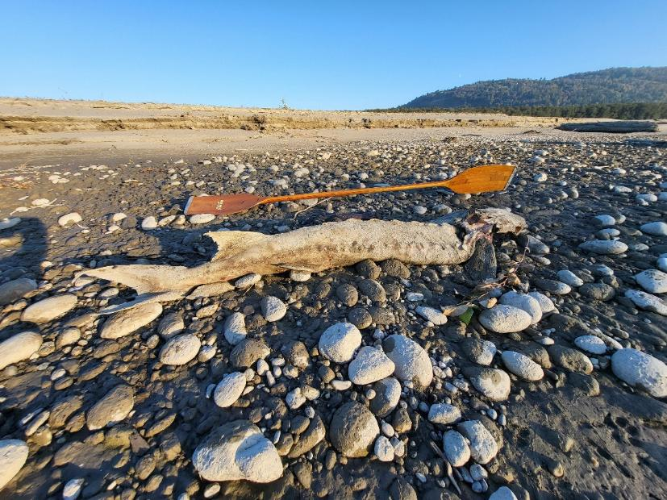
Dead Sturgeon along accreting shoreline. Kayak paddle included for scale. Scavengers had ripped apart its neck and next day all its innards were gone with many coyote footprints around.

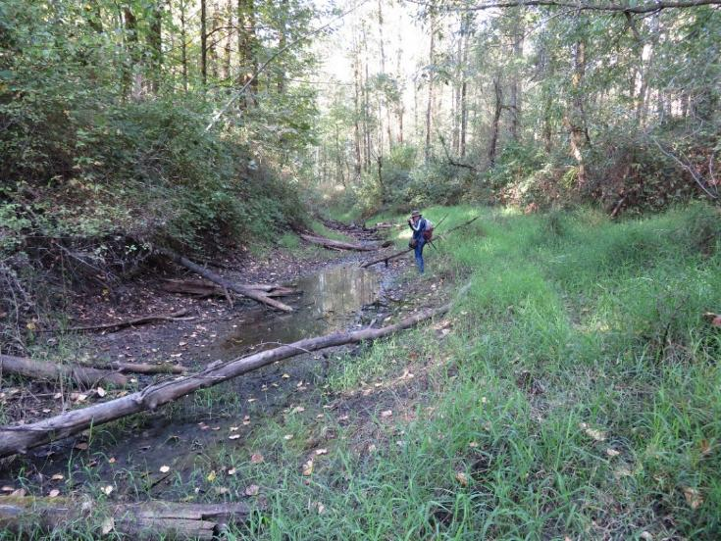
Interior pool on largest downriver island where several tadpoles were seen.
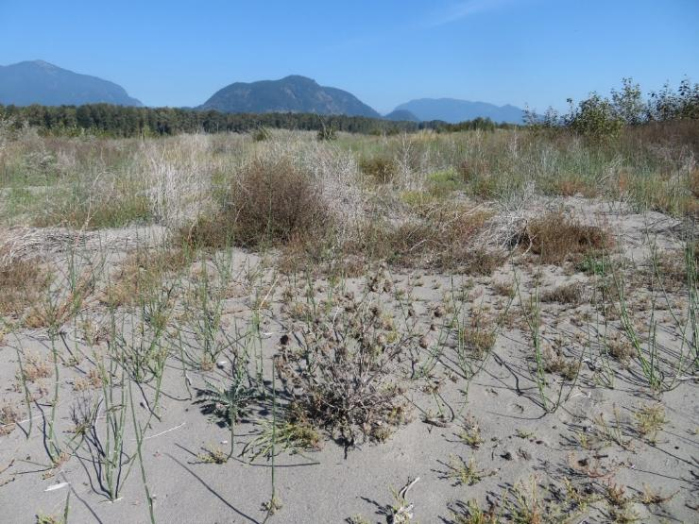
With this very dry summer and low water level of the Fraser River, the vegetation on accreting shorelines was more scattered than in previous years and stunted.

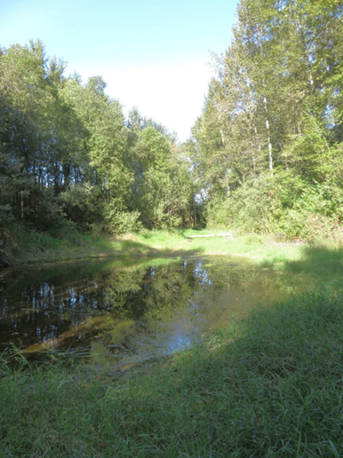
Interior pool still holds considerable water, possibly with clay and silt acting as membrane. Tadpoles visible in this pool
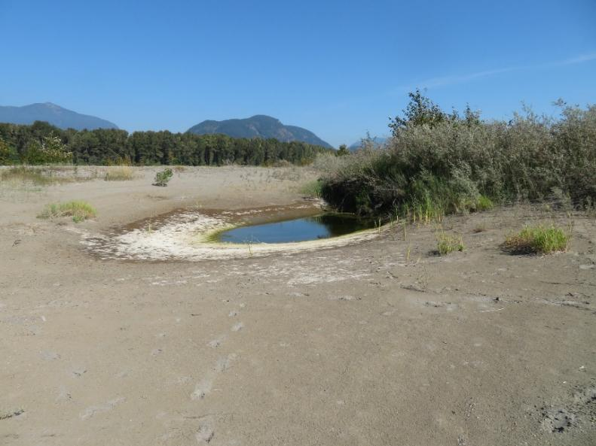
Drying up pool adjacent to Sand Dune area accreting near largest upriver island.

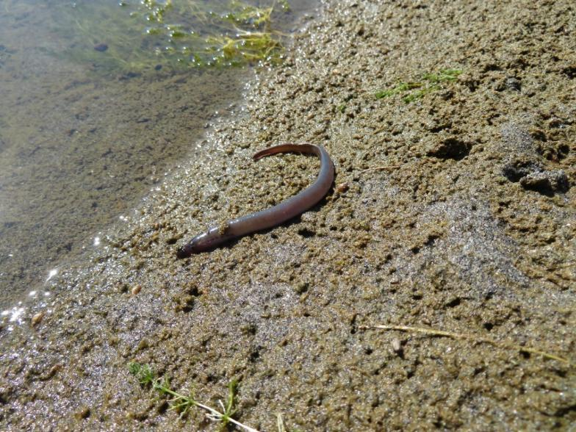
Possible Northern Lamprey, Family Petromyzontidae sunning itself. Likely it has just emerged from the mud, having transformed from its larva form. It swam well when pushed back in watered. Four other similar ones seen sunning beside another pool.

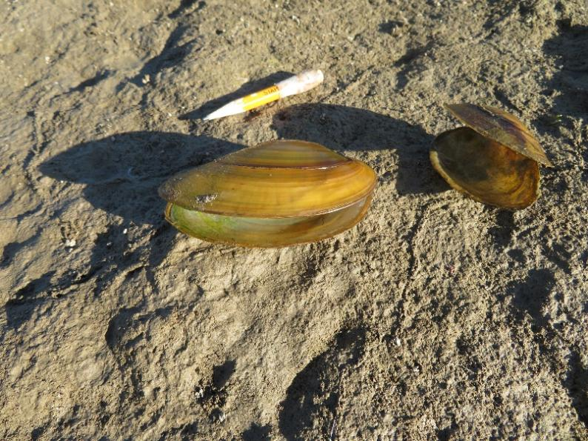
Two empty mussell shells of Western/Oregon Floater (Anodonata kennerlyi/oregonensis clade) found in shallow water at edge of drying out pool.

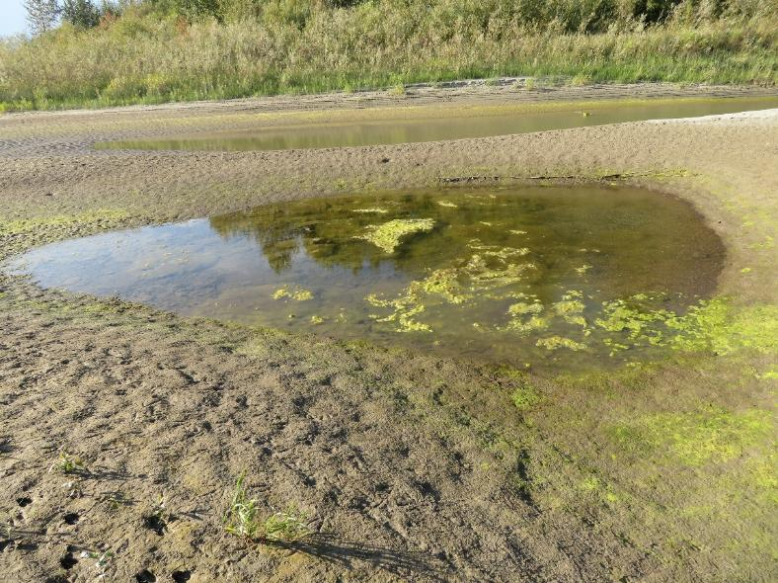
Pool that would have been flowing river channel with higher water in the Fraser, now drying up.
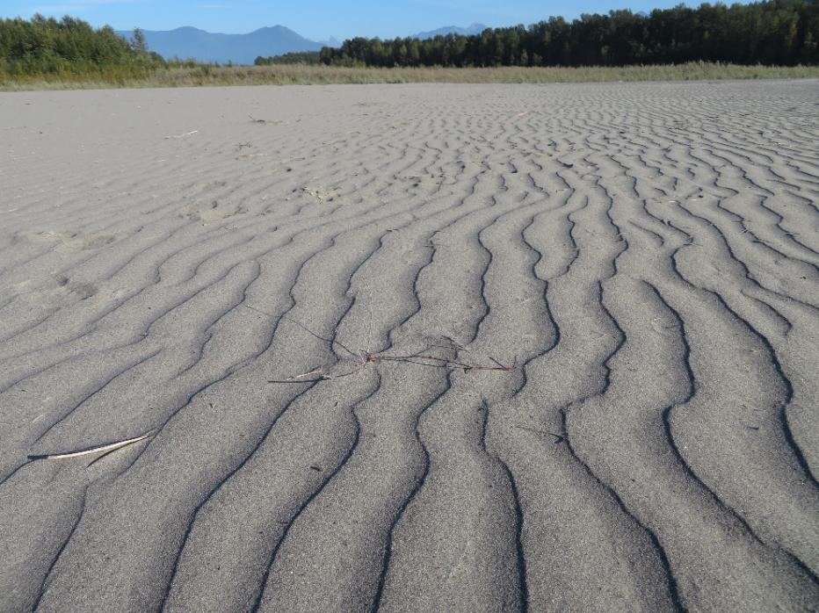
Sand sculptures across accreting shoreline.

