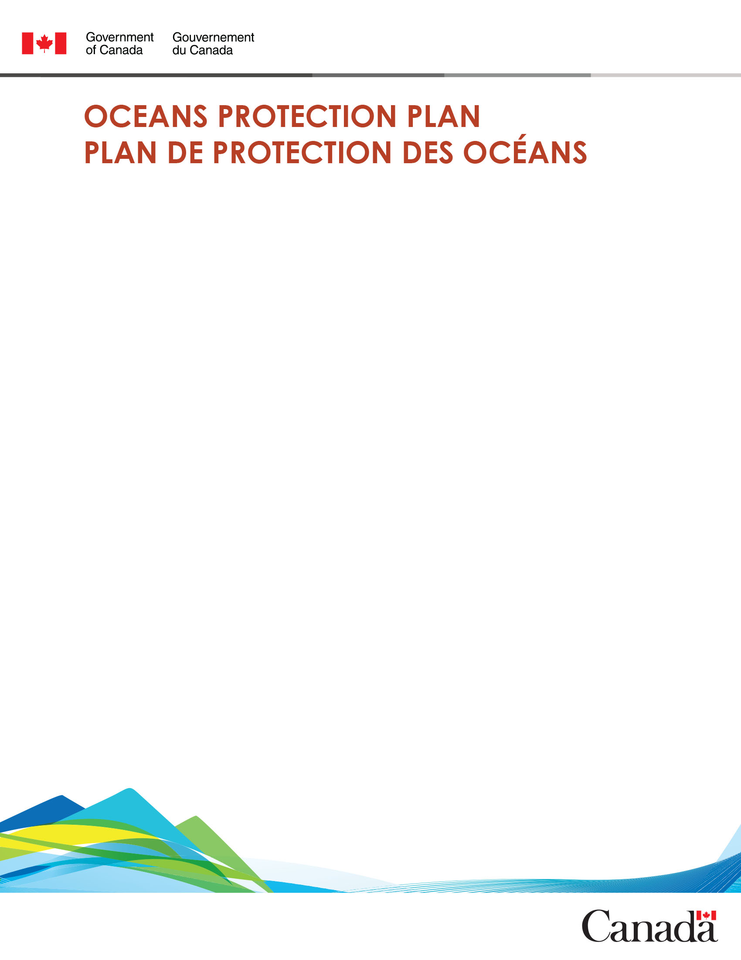

**Oceans Protection Plan (OPP) Dialogue Forum**

**February 17-19, 2021**

**Objectives:**

* Share information about progress on Oceans Protection Plan and related initiatives, with a focus

on partnerships

* Provide opportunities for participants to be engaged, or learn about future opportunities

for engagement in specific initiatives

* Provide an opportunity for networking and learning across sectors

**Agenda - Day 1: Wednesday, February 17, 2021**

**Theme: Overview and Environmental Protection**

|  |  |
| --- | --- |
| **Time** | **Session Description** |
| **8:10 – 8:25** | **Tech Check and Login** |
| **Session One: 8:25 am to 9:15 am** | |
| **8:25 – 8:45** | **Part A: Welcome to the Oceans Protection Plan (OPP) Dialogue Forum** |
|  | * Welcome and Introductions – Andrew Bak, Senior Program Officer, OPP, Transport Canada * Opening Ceremony – Larry Grant, Elder, Musqueam * Logistics Overview – Andrew Bak, Senior Program Officer, OPP, Transport Canada * Questions for Participants – Andrew Bak, Senior Program Officer, OPP, Transport Canada |
| **8:45 – 9:05** | **Part B: Overview of the Oceans Protection Plan (OPP)** |
|  | Presentation: OPP Progress and Accomplishments to Date   * Trevor Heryet, Executive Director, OPP, Transport Canada |
| **9:05 – 9:15** | **Part C: Questions and Answers** |
|  | Moderator: Cecilia Lei, Regional Director, Transport Canada   * Trevor Heryet, Executive Director, OPP, Transport Canada |

|  |  |
| --- | --- |
| **9:15 – 9:30** | **Transition Break (15 minutes] – Participants to join via video-stream link provided** |
| **Session Two: 9:30 am to 11:45 am** | |
| **9:30 – 11:45** | **Concurrent Sessions: Information Briefs** |
|  | * 3 rounds of 35-minute sessions, running concurrently, 15 minute break after each round |
| **9:30 – 10:05**  **Round One** | **Info Brief Tables:**  **Anchorages Initiative**   * This presentation will provide an update on the Anchorages Initiative * Emilie Gelinas, Director, Domestic Marine Policy, Transport Canada   **Marine Birds and Shorelines in BC: Collection of Baseline Data**   * This session will provide an overview of work to date towards monitoring and conservation of marine birds, from at-sea surveys and GPS tracking to biomonitoring and ecotoxicology studies. In addition, an update on coastal shoreline aerial imagery and segmentation for the BC coastline will provided. * Greg McClelland, Wildlife Biologist, Environment and Climate Change Canada; Sarah Hudson, Wildlife Research Coordinator, Environment and Climate Change Canada   **Reducing the Threats to Marine Mammals**   * This session will focus on a few of the ways we are working to reduce the threats to marine mammals, including the endangered Southern Resident Killer Whale. * Shinjini Pilon, Program Scientist, Environment and Climate Change Canada; Abigail Fyfe, Senior Research Development Officer, Transport Canada; Meaghen McCord, Marine Ecologist, Parks Canada; Kristy Walde, Senior Compliance Officer, Department of Fisheries and Oceans Canada   **An Introduction to the Wrecked & Abandoned Hazardous Vessels Act**   * An update on the status and implementation of the National Strategy on Abandoned and Wrecked Vessels. * Ryan Greville, Manager, Navigation Protection Program, Transport Canada   **The Effects of Climate Change on Coastal Hazards in BC and Nature-based Shore**  **Protection Solutions to Mitigate Flood and Erosion Risks**   * This presentation will describe recent research at the National Research Council of Canada that investigates the expected impacts of climate change on storm surges, wave conditions and coastal hazards in BC coastal waters. Current research on nature-based features and natural infrastructure solutions suitable for mitigating coastal erosion and flood risks in manner that is harmonious with nature will also be described. * Andrew Cornett, Principal Research Officer, National Research Council Canada; Enda Murphy, Senior Research Engineer National Research Council Canada; Sean Ferguson, Researcher National Research Council, Canada |
| **10:05 – 10:20**  **Break** |
| **10:20 – 10:55**  **Round Two** |
| **10:55 – 11:10**  **Break** |
| **11:10 – 11:45**  **Round Three** |
| **11:45 – 12:15** | **Lunch Break (30 minutes)** |
| **12:15 – 12:30** | **Transition to Networking Session (15 minutes) – Participants to access session using link provided** |
| **12:30 – 12:50** | **Networking Session** |
| **12:50 – 1:00** | **Transition to Panel Discussion (10 minutes) – Participants to join live-stream video link provided** |
| **Session Three: 1:00 pm to 1:30 pm** | |
| **1:00 – 1:25** | **Panel Discussion: Oceans Protection Plan Progress and Accomplishments to Date** |
|  | Moderator: Cecilia Lei, Regional Director, OPP, Transport Canada    Panel:   * Brigid Payne, Regional Director, Oceans and Salmonid Enhancement, Department of Fisheries and Oceans Canada * Tanya Bryant, Director, Environmental Emergencies Division, Environment and Climate Change Canada * David Heap, A/Senior Director Transformation, Engagement and Partnerships, Canadian Coast Guard * Trevor Heryet, Executive Director, Oceans Protection Plan, Transport Canada |
| **1:25** | **Day One Closing Remarks**   * Trevor Heryet, Executive Director, OPP, Transport Canada |
| **1:30** | **Day One Adjourns** |

**Agenda - Day 2: Thursday, February 18, 2021**

**Theme: Prevention and Partnerships**

|  |  |
| --- | --- |
| **Time** | **Session Description** |
| **8:15 – 8:30** | **Tech Check and Login** |
| **Session One: 8:30 am to 10:00 am** | |
| **8:30 – 8:40** | **Part A: Welcome and Introductions** |
|  | * Welcome and Introductions – Andrew Bak, Senior Program Officer, OPP, Transport Canada * Logistics Overview – Andrew Bak, Senior Program Officer, OPP, Transport * Questions for Participants – Andrew Bak, Senior Program Officer, OPP, Transport |
| **8:40 – 9:20** | **Part B: Indigenous Partnerships – Oceans Protection Plan (OPP) Partnership Projects** |
|  | **Council of** **Haida Nation Presentation: Establishing a Safe Distance Offshore for Marine**  **Shipping in Haida Gwaii**   * Russ Jones, Senior Consultant, Marine Planning Program, Council of Haida Nation * Olivia Choi, Marine Awareness Information Analyst, Council of Haida Nation * Louise Murgatroyd, Program Manager, OPP, Transport Canada * Robert Lewis-Manning, President, BC Chamber of Shipping   **First Nations Fisheries Council Presentation: Collaboration on the Cumulative Effects of Marine Shipping Initiative in South Coast BC**   * Paula Doucette, Senior Environmental Assessment Advisor, OPP, Transport Canada * Astrid Niemann-Zajac, Senior Manager, Economic Opportunities and Partnership, First Nations Fisheries Council * Aline Carrier, Capacity Building Coordinator, Nuu-chah-nulth |
| **9:20 – 10:00** | **Part C: Panel Discussion and Q&A** |
|  | Moderator: Joy William, Senior Program Officer, Transport Canada and Jordan Brears, Program  Policy Analyst, Transport Canada   * Russ Jones, Senior Consultant, Marine Planning Program, Council of Haida Nation * Olivia Choi, Marine Awareness Information Analyst, Council of Haida Nation * Louise Murgatroyd, Program Manager, OPP, Transport Canada * Robert Lewis-Manning, President, Chamber of Shipping * Aline Carrier, Capacity Building Coordinator, Nuu-chah-nulth * Paula Doucette, Senior Environmental Assessment Advisor, OPP, Transport Canada |
| **10:00 – 10:15** | **Transition Break (15 minutes] – Participants to join video-stream link provided** |

|  |  |
| --- | --- |
| **Session Two: 10:15 am to 11:35 am** | |
| **10:15 – 11:35** | **Concurrent Sessions: Information Briefs** |
|  | * 2 rounds of 35-minute sessions, running concurrently, 15 minute break in between |
| **10:15 - 10:50**  **Round One** | **Info Brief Tables:**  **Navigating Deckhand Training – Pandemic Edition**   * This presentation will discuss the progress, challenges, & plans for training Indigenous and women for entry level positions at sea during the pandemic. * John Dymond, Business Development Manager, BC Institute of Technology; Debbie Power, Program Coordinator, BC Institute of Technology; Steve Walker-Duncan, Chair, Trades Development & Special Projects, Camosun College; Cindy Drover-Davidson, Program Coordinator, Camosun College   **Overview of Cumulative Effects of Marine Shipping OPP Initiative – Progress at**  **Pacific Pilot Sites and the Development of a National Framework**   * The session will provide an overview of the development of the CEMS National Framework as well as the approaches being taken to conduct regional CEMS assessments at the Northern Shelf Bioregion and South Coast, British Columbia pilot sites. * Paula Doucette, Senior Environmental Assessment Advisor, OPP, Transport Canada; Sam Mansfield, Environmental Officer, OPP, Transport Canada   **Investigating Next-gen Oil Spill Response Boom Concepts Delivering Improved**  **Performance at Higher Flow/Tow Speeds**   * This presentation will describe recent research at the National Research Council of Canada supporting the development of new types of booms delivering effective retention of floating oil at markedly higher flow/tow speeds than conventional boom designs. Numerical simulations of oil-water-boom interactions and lab testing of 1/8 scale models of several innovative boom concepts at speeds up to 3 knots will be described and discussed. * Hossein Babaei, Researcher, National Research Council; Scott Baker, Researcher, National Research Council   **Applying Big Data Techniques to Improve Fuel Consumption on Ships**   * This presentation will provide an overview of two studies undertaken by the National Research Council’s Ocean, Coastal and River Engineering Research Centre that focus on applying machine learning techniques to vessel operational data to develop data products that will help to inform improved vessel fuel efficiency. * Allison Kennedy, Research Officer, National Research Council |
| **10:50 – 11:05**  **Break** |
| **11:05 – 11:40**  **Round Two** |
| **11:40 – 12:10** | **Lunch Break (30 minutes)** |
| **12:10 – 12:20** | **Transition to Workshops – Participants to join video-stream link based on workshop of interest** |

|  |  |
| --- | --- |
| **Session Three: 12:20 pm to 1:30 pm** | |
| **12:20 – 1:30** | **Concurrent Workshops on Oceans Protection Plan (OPP) Initiatives** |
|  | * Workshops will feature OPP initiatives and run one hour & 10 minutes   Workshops:  **Enhanced Maritime Situational Awareness**   * The Enhanced Maritime Situational Awareness (EMSA) system provides Indigenous and coastal communities with near real-time information on maritime activity in local waters through a user-friendly web platform. This workshop will be co-presented by pilot-host partners, Tseycum First Nation and Malahat Nation, and will highlight their community work using the EMSA system. * Kelly Larkin, Regional Program Manager, Transport Canada; Michael Kim, Program Policy Analyst, OPP, Transport Canada; Olivia Hall, Program Advisor, OPP, Transport Canada; * William Morris; Tseycum First Nation; Peter Evans, Director, Research and Outreach, Trailmark Systems and Consulting; Ed Ross, Senior Project Manager, Trailmark Systems and Consulting, Beth Keats, Research Associate, Trailmark Systems and Consulting; * William Hall, Web Mapping Coordinator, Malahat Nation; Desiree Bulger, Web Mapping Coordinator, Malahat Nation, Tristan Gale, Executive Director, Environment and Sustainable Development, Malahat Nation   **OPP Progress, Transformation and New Products (Canadian Hydrographic Service)**   * This session will provide a brief overview of OPP progress, transformation initiatives and new products including dynamic hydrographic products. * Stacey Verrin, Manager, Data Acquisition & Technical Services, Canadian Hydrographic Service; Peter Wills, Manager of Navigation Products and Services, Canadian Hydrographic Service; Fraser Davidson, Research Scientist and Coordinator Dynamic Hydrographic Products, Canadian Hydrographic Service, Department of Fisheries and Oceans Canada   **Emergency Towing: Marine Navigational Risk Assessment Proposed Approach**   * This presentation will provide an update on the emergency towing initiative and provide a general overview of a proposed approach for a marine navigational risk assessment for this initiative. * James Cook, Program Policy Analyst, Transport Canada |
| **1:30** | **Day Two Adjourns** |

**Agenda - Day 3: Friday, February 19, 2021**

**Theme: Preparedness and Response**

|  |  |
| --- | --- |
| **Time** | **Session Description** |
| **8:15 – 8:30** | **Tech Check and Login** |
| **Session One: 8:30 am to 8:35 am** | |
| **8:30** | **Welcome** |
|  | * Welcome – Andrew Bak, Senior Program Officer, OPP, Transport Canada * Logistics Overview – Andrew Bak, Senior Program Officer, OPP, Transport Canada * Questions for Participants – Andrew Bak, Senior Program Officer, OPP, Transport Canada |
| **8:35 – 8:50** | **Transition to Workshops (15 minutes) – Participants to join via video-stream link provided** |
| **Session Two: 8:50 am to 11:25 am** | |
| **8:50 – 11:25** | **Concurrent Workshops** |
|  | * 1 hour and 10 minute workshops with 15 minute break between rounds |
| **8:50 – 10:00**  **Round One** | **Workshops:**  **Who Pays for an Oil Spill in Canadian Waters and What Should be Covered? Liability and**  **Compensation for Marine Incidents**   * We’re always working to improve our system for marine liability and compensation to better protect Canadians and we want to hear from you. We’d like you to tell us how an oil spill caused by a ship could cause damage or losses to your community. * Kayla Glynn, Policy Analyst, International Marine Policy and Liability, Transport Canada   **Advances in Oil Spill Science to Support Response Operations**   * An overview of advances in scientific knowledge to improve decision making during emergency response operations. Included is a description of emerging technologies to expand Canada’s “toolbox” for oil spill clean-up * Kenneth Lee, National Senior Science Advisor, Oil Spill Research, Preparedness and Response, Department of Fisheries and Oceans Canada   **Recovery from Environmental Emergencies Involving Ship-Source Oil Spills**   * The Government of Canada is conducting an analysis to clarify the roles and responsibilities for recovery from marine environmental emergencies, and bringing forward options for legislative, policy and program changes. * Josée Simard, Manager, Environmental Emergencies Policy, Environment and Climate Change Canada |
| **10:00 – 10:15**  **Break** |
| **10:15 – 11:25**  **Round Two** |
| **11:25 – 11:40** | **Transition to Lunch Panel Discussion (15 minutes) – Participants to join via the live-stream**  **video link provided** |
| **Session Three: 11:40 am to 12:20 pm** | |
| **11:40 – 11:55** | **Keynote Speech** |
|  | * Robert Dick, Assistant Deputy Minister, Transport Canada |

|  |  |
| --- | --- |
| **11:55 – 12:15** | **Panel: Closing Reflections** |
|  | Moderator: Andrew Bak, Senior Program Officer, OPP, Transport Canada   * Brigid Payne, Regional Director, Oceans and Salmonid Enhancement, Department of Fisheries and Oceans Canada * Tanya Bryant, Director, Environmental Emergencies Division, Environment and Climate Change Canada * David Heap, A/Senior Director Transformation, Engagement and Partnerships, Canadian Coast Guard * Cecilia Lei, Regional Director, OPP, Transport Canada |
| **12: 15 – 12:25** | **Closing Ceremony** |
|  | * Andrew Bak, Senior Program Officer, OPP, Transport Canada * Larry Grant, Elder, Musqueam |
| **12:25** | **Day Three Adjourns – End of Forum** |